Lab Assignment No: 04

Problem statement: AWT and Swing

**Design a java application to demonstrate GUI and event handling using Swing to perform simple and complex mathematical operations**

NAME: Chaitanya S. Joshi ROLLNO: 26

CLASS: SYMCA BRANCH: MCA BATCH: B1

DATE OF PERFORMANCE:18/03/2021

Question:

**Design a java application to demonstrate GUI and event handling using Swing to perform simple and complex mathematical operations**

Solution:

import java.awt.*;

import javax.swing.*;

import java.awt.event.*;

import javax.swing.event.*;

public class SciCalci extends JFrame implements ActionListener

{

JTextField tfield;

double temp, temp1, result, a;

static double m1, m2;

int k = 1, x = 0, y = 0, z = 0;

char ch;

JButton b1, b2, b3, b4, b5, b6, b7, b8, b9, zero, clr, pow2, pow3, exp,

fac, plus, min, div, log, rec, mul, eq, addSub, dot, sqrt, sin, cos, tan;

Container cont;

JPanel textPanel, buttonpanel;

SciCalci()

{

cont = getContentPane();

cont.setLayout(new BorderLayout());

JPanel textpanel = new JPanel();

tfield = new JTextField(25);

tfield.setHorizontalAlignment(SwingConstants.RIGHT);

tfield.addKeyListener(new KeyAdapter() {

public void keyTyped(KeyEvent keyevent)

{

char c = keyevent.getKeyChar();

}

});

textpanel.add(tfield);

buttonpanel = new JPanel();

buttonpanel.setLayout(new GridLayout(8, 4, 2, 2));

boolean t = true;

b1 = new JButton("1");

buttonpanel.add(b1);

b1.addActionListener(this);

b2 = new JButton("2");

buttonpanel.add(b2);

b2.addActionListener(this);

b3 = new JButton("3");

buttonpanel.add(b3);

b3.addActionListener(this);

b4 = new JButton("4");

buttonpanel.add(b4);

b4.addActionListener(this);

b5 = new JButton("5");

buttonpanel.add(b5);

b5.addActionListener(this);

b6 = new JButton("6");

buttonpanel.add(b6);

b6.addActionListener(this);

b7 = new JButton("7");

buttonpanel.add(b7);

b7.addActionListener(this);

b8 = new JButton("8");

buttonpanel.add(b8);

b8.addActionListener(this);

b9 = new JButton("9");

buttonpanel.add(b9);

b9.addActionListener(this);

zero = new JButton("0");

buttonpanel.add(zero);

zero.addActionListener(this);

plus = new JButton("+");

buttonpanel.add(plus);

plus.addActionListener(this);

min = new JButton("-");

buttonpanel.add(min);

min.addActionListener(this);

mul = new JButton("*");

buttonpanel.add(mul);

mul.addActionListener(this);

div = new JButton("/");

div.addActionListener(this);

buttonpanel.add(div);

addSub = new JButton("+/-");

buttonpanel.add(addSub);

addSub.addActionListener(this);

dot = new JButton(".");

buttonpanel.add(dot);

dot.addActionListener(this);

eq = new JButton("=");

buttonpanel.add(eq);

eq.addActionListener(this);

rec = new JButton("1/x");

buttonpanel.add(rec);

rec.addActionListener(this);

sqrt = new JButton("Sqrt");

buttonpanel.add(sqrt);

sqrt.addActionListener(this);

log = new JButton("log");

buttonpanel.add(log);

log.addActionListener(this);

sin = new JButton("SIN");

buttonpanel.add(sin);

sin.addActionListener(this);

cos = new JButton("COS");

buttonpanel.add(cos);

cos.addActionListener(this);

tan = new JButton("TAN");

buttonpanel.add(tan);

tan.addActionListener(this);

pow2 = new JButton("x^2");

buttonpanel.add(pow2);

pow2.addActionListener(this);

pow3 = new JButton("x^3");

buttonpanel.add(pow3);

pow3.addActionListener(this);

exp = new JButton("Exp");

exp.addActionListener(this);

buttonpanel.add(exp);

fac = new JButton("n!");

fac.addActionListener(this);

buttonpanel.add(fac);

clr = new JButton("CLR");

buttonpanel.add(clr);

clr.addActionListener(this);

cont.add("Center", buttonpanel);

cont.add("North", textpanel);

setDefaultCloseOperation(JFrame.EXIT_ON_CLOSE);

setSize(500,500);

}

public void actionPerformed(ActionEvent e)

{

String s = e.getActionCommand();

if (s.equals("1")) {

if (z == 0) {

tfield.setText(tfield.getText() + "1");

} else {

tfield.setText("");

tfield.setText(tfield.getText() + "1");

z = 0;

}

}

if (s.equals("2")) {

if (z == 0) {

tfield.setText(tfield.getText() + "2");

} else {

tfield.setText("");

tfield.setText(tfield.getText() + "2");

z = 0;

}

}

if (s.equals("3")) {

if (z == 0) {

tfield.setText(tfield.getText() + "3");

} else {

tfield.setText("");

tfield.setText(tfield.getText() + "3");

z = 0;

}

}

if (s.equals("4")) {

if (z == 0) {

tfield.setText(tfield.getText() + "4");

} else {

tfield.setText("");

tfield.setText(tfield.getText() + "4");

z = 0;

}

}

if (s.equals("5")) {

if (z == 0) {

tfield.setText(tfield.getText() + "5");

} else {

tfield.setText("");

tfield.setText(tfield.getText() + "5");

z = 0;

}

}

if (s.equals("6")) {

if (z == 0) {

tfield.setText(tfield.getText() + "6");

} else {

tfield.setText("");

tfield.setText(tfield.getText() + "6");

z = 0;

}

}

if (s.equals("7")) {

if (z == 0) {

tfield.setText(tfield.getText() + "7");

} else {

tfield.setText("");

tfield.setText(tfield.getText() + "7");

z = 0;

}

}

if (s.equals("8")) {

if (z == 0) {

tfield.setText(tfield.getText() + "8");

} else {

tfield.setText("");

tfield.setText(tfield.getText() + "8");

z = 0;

}

}

if (s.equals("9")) {

if (z == 0) {

tfield.setText(tfield.getText() + "9");

} else {

tfield.setText("");

tfield.setText(tfield.getText() + "9");

z = 0;

}

}

if (s.equals("0"))

{

if (z == 0) {

tfield.setText(tfield.getText() + "0");

} else {

tfield.setText("");

tfield.setText(tfield.getText() + "0");

z = 0;

}

}

if (s.equals("CLR"))

{

tfield.setText("");

x = 0;

y = 0;

z = 0;

}

if (s.equals("log")) {

if (tfield.getText().equals("")) {

tfield.setText("");

} else {

a = Math.log(Double.parseDouble(tfield.getText()));

tfield.setText("");

tfield.setText(tfield.getText() + a);

}

}

if (s.equals("1/x")) {

if (tfield.getText().equals("")) {

tfield.setText("");

} else {

a = 1 / Double.parseDouble(tfield.getText());

tfield.setText("");

tfield.setText(tfield.getText() + a);

}

}

if (s.equals("Exp")) {

if (tfield.getText().equals("")) {

tfield.setText("");

} else {

a = Math.exp(Double.parseDouble(tfield.getText()));

tfield.setText("");

tfield.setText(tfield.getText() + a);

}

}

if (s.equals("x^2")) {

if (tfield.getText().equals("")) {

tfield.setText("");

} else {

a = Math.pow(Double.parseDouble(tfield.getText()), 2);

tfield.setText("");

tfield.setText(tfield.getText() + a);

}

}

if (s.equals("x^3")) {

if (tfield.getText().equals("")) {

tfield.setText("");

} else {

a = Math.pow(Double.parseDouble(tfield.getText()), 3);

tfield.setText("");

tfield.setText(tfield.getText() + a);

}

}

if (s.equals("+/-")) {

if (x == 0) {

tfield.setText("-" + tfield.getText());

x = 1;

} else {

tfield.setText(tfield.getText());

}

}

if (s.equals(".")) {

if (y == 0) {

tfield.setText(tfield.getText() + ".");

y = 1;

} else {

tfield.setText(tfield.getText());

}

}

if (s.equals("+")) {

if (tfield.getText().equals("")) {

tfield.setText("");

temp = 0;

ch = '+';

} else {

temp = Double.parseDouble(tfield.getText());

tfield.setText("");

ch = '+';

y = 0;

x = 0;

}

tfield.requestFocus();

}

if (s.equals("-")) {

if (tfield.getText().equals("")) {

tfield.setText("");

temp = 0;

ch = '-';

} else {

x = 0;

y = 0;

temp = Double.parseDouble(tfield.getText());

tfield.setText("");

ch = '-';

}

}

if (s.equals("/")) {

if (tfield.getText().equals("")) {

tfield.setText("");

temp = 1;

ch = '/';

} else {

x = 0;

y = 0;

temp = Double.parseDouble(tfield.getText());

ch = '/';

tfield.setText("");

}

}

if (s.equals("*")) {

if (tfield.getText().equals("")) {

tfield.setText("");

temp = 1;

ch = '*';

} else {

x = 0;

y = 0;

temp = Double.parseDouble(tfield.getText());

ch = '*';

tfield.setText("");

}

}

if (s.equals("Sqrt")) {

if (tfield.getText().equals("")) {

tfield.setText("");

} else {

a = Math.sqrt(Double.parseDouble(tfield.getText()));

tfield.setText("");

tfield.setText(tfield.getText() + a);

}

}

if (s.equals("SIN")) {

if (tfield.getText().equals("")) {

tfield.setText("");

} else {

a = Math.sin(Double.parseDouble(tfield.getText()));

tfield.setText("");

tfield.setText(tfield.getText() + a);

}

}

if (s.equals("COS")) {

if (tfield.getText().equals("")) {

tfield.setText("");

} else {

a = Math.cos(Double.parseDouble(tfield.getText()));

tfield.setText("");

tfield.setText(tfield.getText() + a);

}

}

if (s.equals("TAN")) {

if (tfield.getText().equals("")) {

tfield.setText("");

} else {

a = Math.tan(Double.parseDouble(tfield.getText()));

tfield.setText("");

tfield.setText(tfield.getText() + a);

}

}

if (s.equals("=")) {

if (tfield.getText().equals("")) {

tfield.setText("");

} else {

temp1 = Double.parseDouble(tfield.getText());

switch (ch) {

case '+':

result = temp + temp1;

break;

case '-':

result = temp - temp1;

break;

case '/':

result = temp / temp1;

break;

case '*':

result = temp * temp1;

break;

}

tfield.setText("");

tfield.setText(tfield.getText() + result);

z = 1;

}

}

if (s.equals("n!")) {

if (tfield.getText().equals("")) {

tfield.setText("");

} else {

a = fact(Double.parseDouble(tfield.getText()));

tfield.setText("");

tfield.setText(tfield.getText() + a);

}

}

}

double fact(double x) {

int er = 0;

if (x < 0) {

er = 20;

return 0;

}

double i, s = 1;

for (i = 2; i <= x; i += 1.0)

s *= i;

return s;

}

public static void main(String args[]) {

SciCalci c = new SciCalci();

c.setTitle("ScientificCalculator");

c.setVisible(true);

c.setSize(500, 400);

}

}

Output:

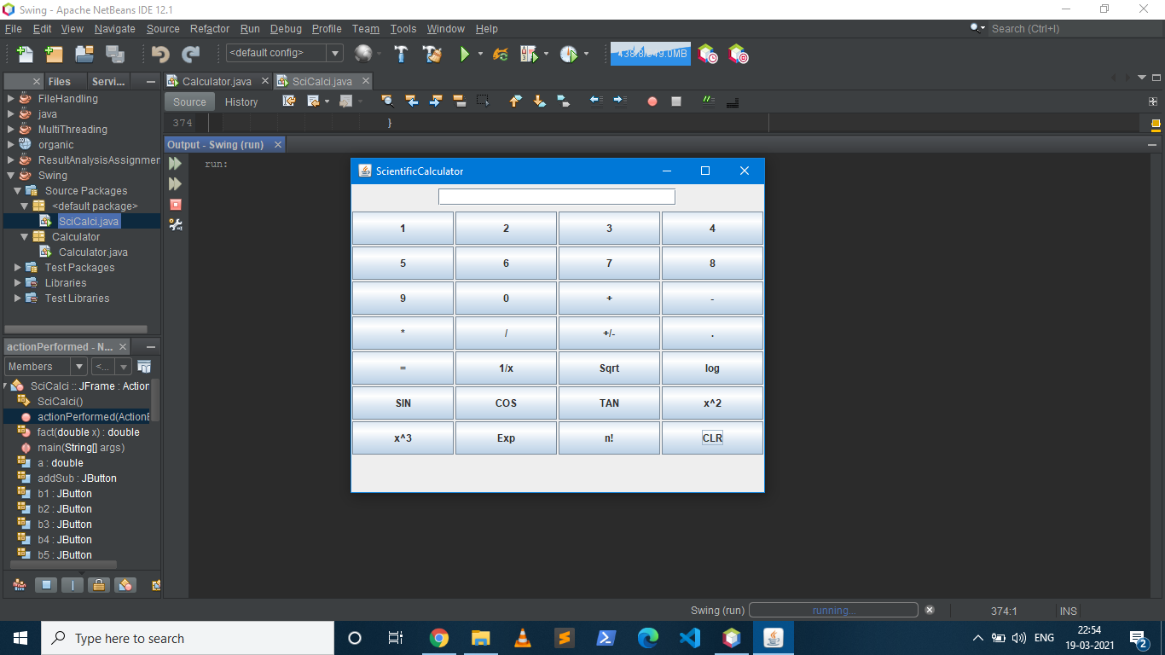

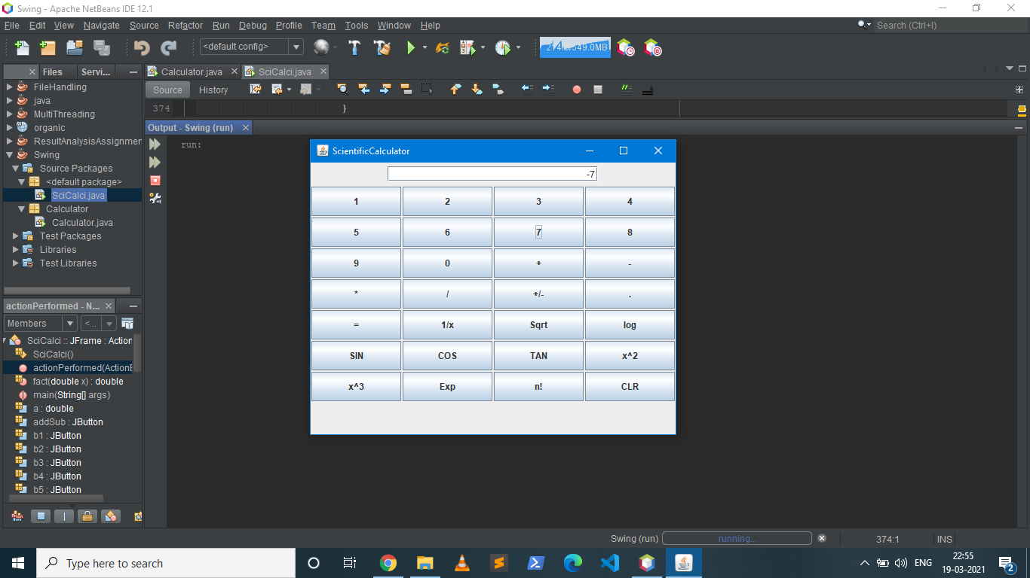

Square of (-7) =

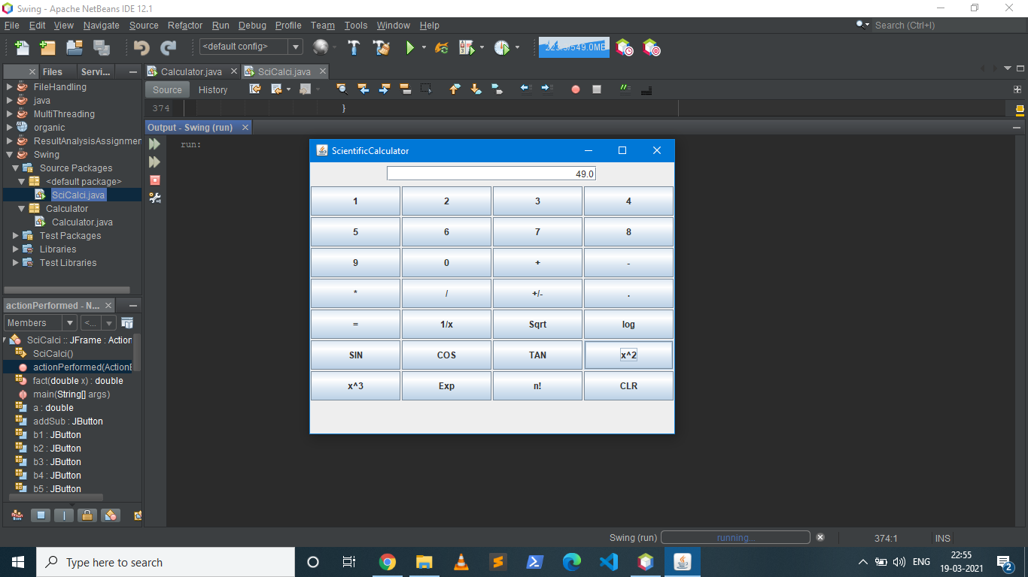

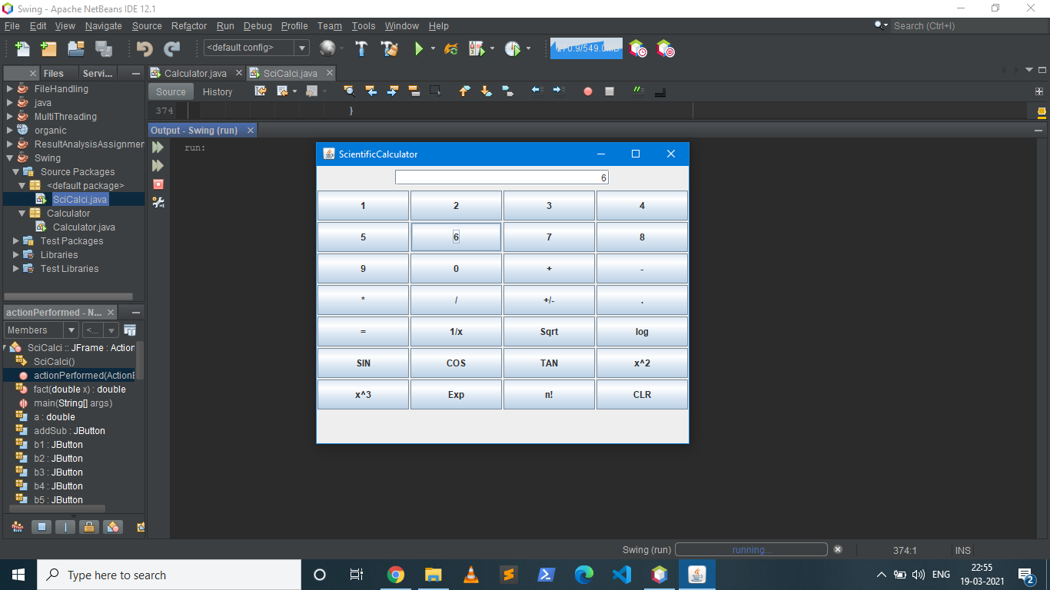

Factorial of 6 =

